Kings Club at Home Sunday 2nd May

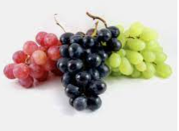
Hello everybody. Do you like fruit? I love fruit and one kind I particularly enjoy is grapes.
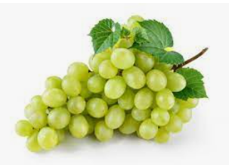

Do you know anything about grapes? They grow in bunches on vines. The vines grow out of the ground and provide nutrition and things that are needed to produce the fruit. Grapes have to stay close to the branches and the vines for them to keep giving fruit.
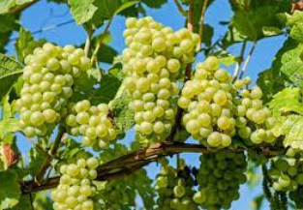
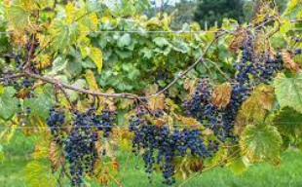
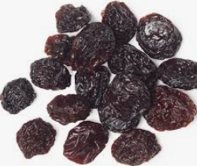
What would happen if one of these grapes fell off the vine and sat in the sun for a while? It wouldn’t be fresh anymore would it? In fact, it would sort of wither and shrivel up like a raisin. There is nothing wrong with a raisin but they don’t look the same as the big, beautiful grapes.

Jesus talked about grapes when he was teaching. You can find today’s Bible passage in John 15 v 1-8. 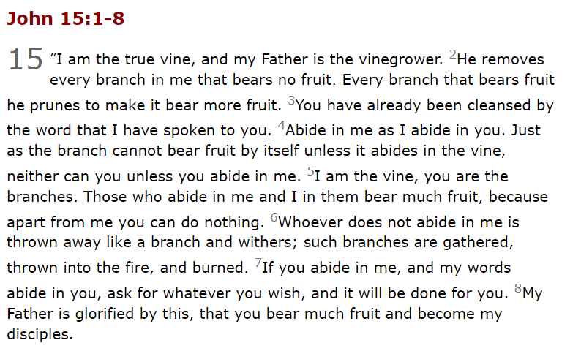
Watch a video about the passage by following this link.
https://www.youtube.com/watch?v=SDlS4otedvY
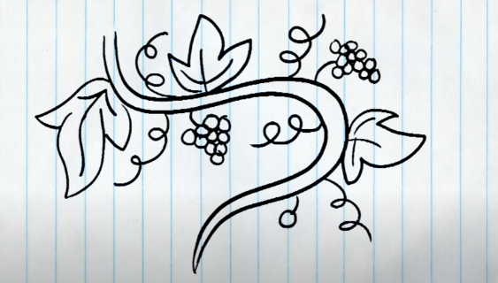

Reflection
The people Jesus were talking to knew a lot about farming and planting and a lot of them probably had vineyards where they grew grapes. Jesus said that God is the gardener or the creator and that he is the vine and that we are the branches.What does that mean?
He was explaining how important it is for us to stay connected to him. Just as the vine provides nutrition that helps the fruit grow on the plant, Jesus gives us all that we need to grow in our faith and live abundant lives. The branches on a grape vine have to stay connected to the vine so that they can produce delicious fruit. Otherwise they will dry up and wither like the sad little raisins. We need to stay close to Jesus so that he can produce ‘fruit’ in us. We don’t grow grapes but we can produce spiritual fruit, things that help others and show that Jesus lives in us. Those are things like joy, peace, patience, kindness, goodness, faithfulness, gentleness and self-control.
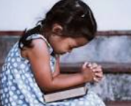
How do we make sure that we are connected to Jesus? We can read and study the Bible, pray and me et together with oth er Christians at church.

If we ever do feel that we are losing our connection, then all we have to do is say sorry for the mistakes we have made and ask for forgiveness and God will welcome us back. How great is that!
Prayer
Dear God,
You are the vine of life. Help us to stay connected to you. We are the branches. Help us to bear spiritual fruit and share with others around us. Thank you for your love. We love you God!
In Jesus’ name, Amen
Music
https://www.youtube.com/watch?v=gET4P4ZQsCQ
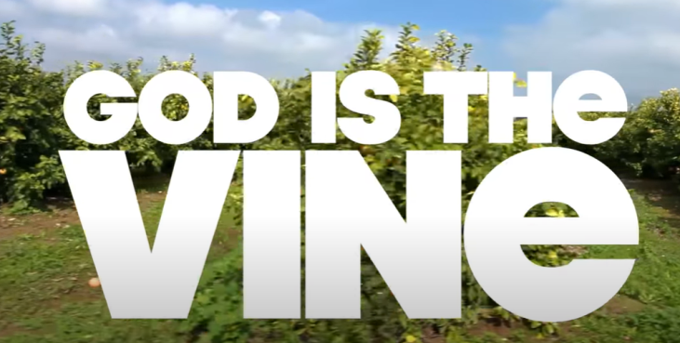

Craft
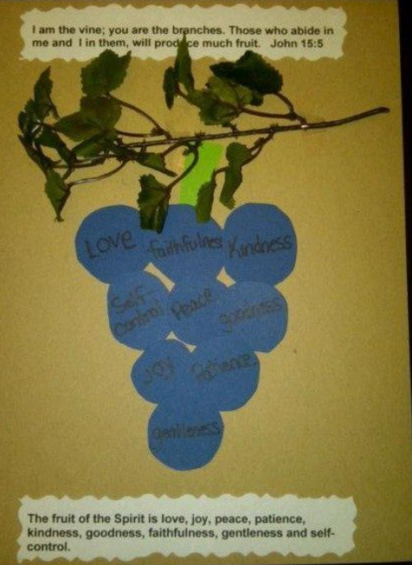
Here is an idea for a craft. You can draw a branch and leaves and colour them in or make one using collage materials.
Next cut out some circles of paper for the grapes. Be careful with the scissors! Remember to ask a grown up to help.
On each grape, write the name of one of the fruits of the spirit. Have fun!

Colouring Sheet

