
Kings Club at Home Sunday 13th December

Welcome back everyone!
Christmas is only 12 days away. Is everything ready for the ‘big day’? Are you ready to say ‘Happy Birthday’ to Jesus?

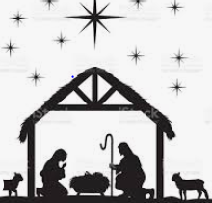

You can enjoy watching the wonderful story of the birth of Jesus by following the link below. It will take you to The Beginners Bible cartoon film of the Nativity.
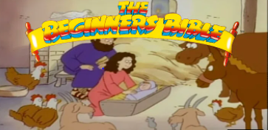

https://www.youtube.com/watch?v=AhuKeFX9HpE

You can also read the story in your Bible - Luke 2 v 1-20.

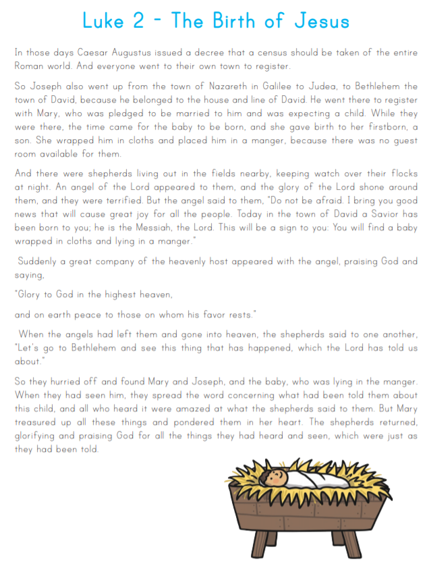
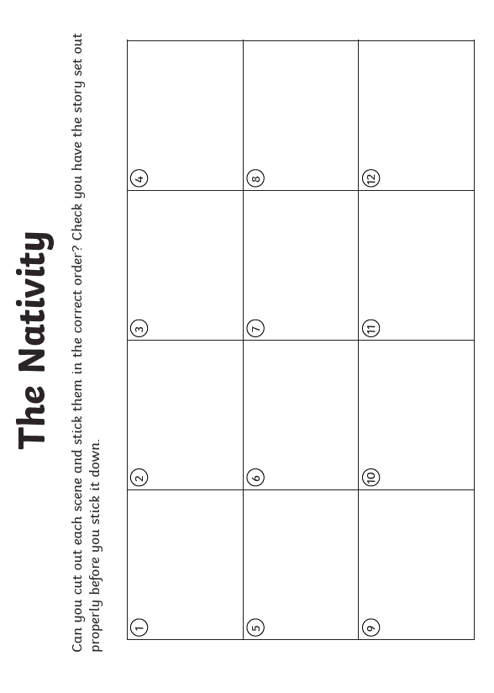
Activity 1 Cut out the pictures from the Nativity story and put them in the right order. Can you retell the story?
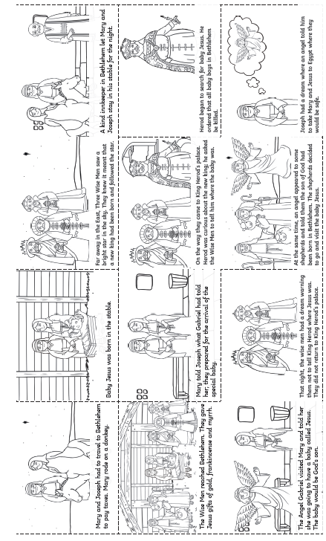
Reflection
The message of the first Christmas is that God loved us so much that he sent his son, Jesus, to us. The best gift we could ever receive! It is because of Jesus that we can be forgiven for all the things that we have ever done wrong and we can live as free people. How amazing is that! This gives us joy for today and hope for tomorrow because where ever we go or whatever we do, God loves us and is with us always. He will never leave us and will help us and is ready to forgive us if we ask him.

Prayer
Dear God,
Thank you for sending Jesus to earth to save us. Thank you that we can celebrate and be happy because of this. Help us to live like Jesus and live a life that pleases you and to have hearts full of peace and love.
Amen
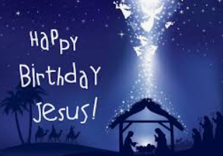

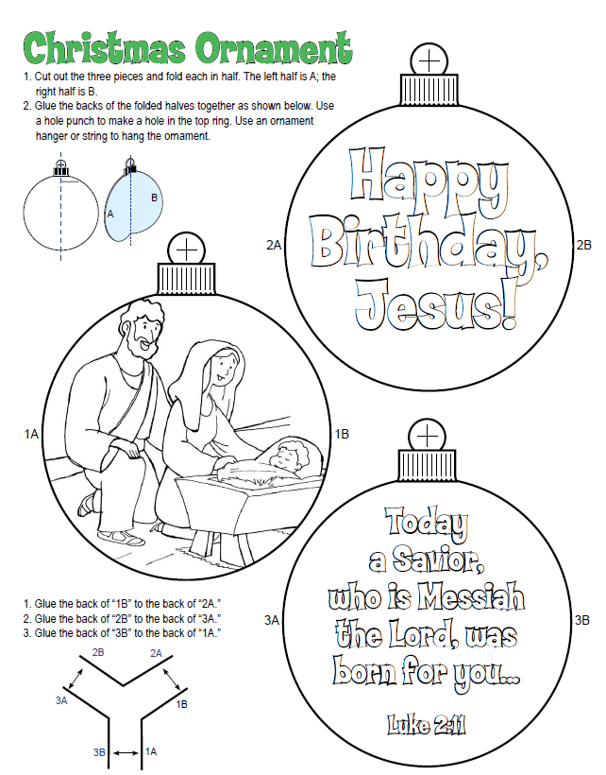
Craft
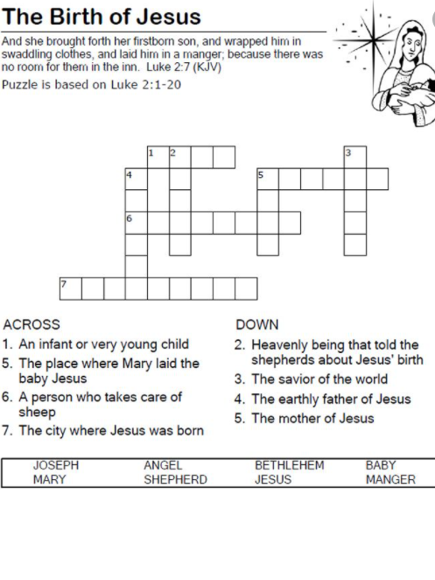
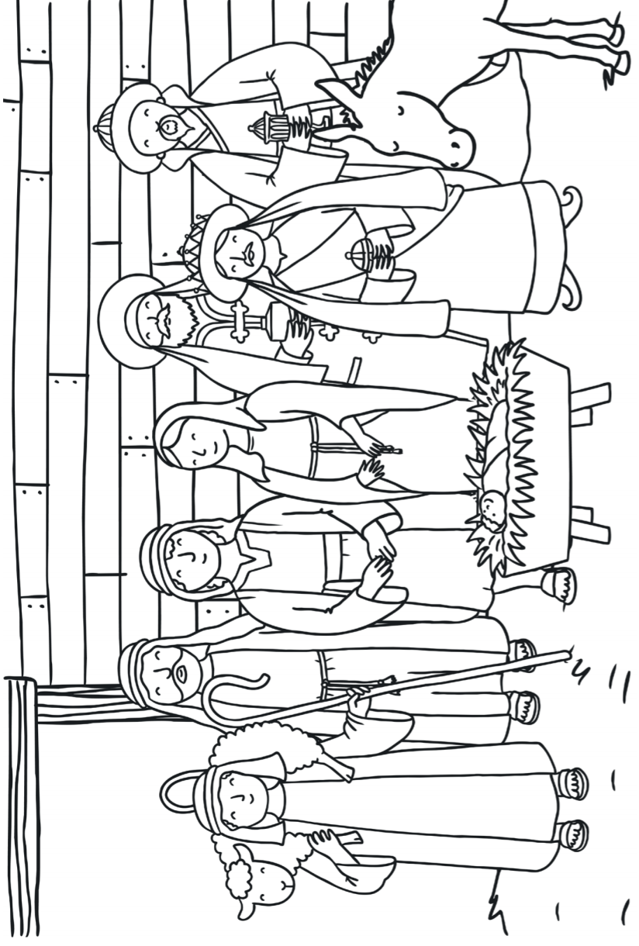
Colouring
Song It was on a Starry Night

https://www.youtube.com/watch?v=UghwPrHKaws

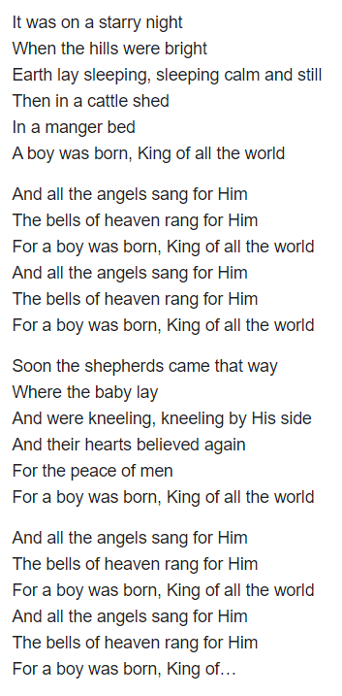
Hope you have enjoyed the activities this week and that you have a joyful and peaceful Christmas.

If you make the craft activity or colour in the sheet take a picture and email it to church.
Email: bilstonbaptistchurch@gmail.com

God bless you all. There will be another Sunday School lesson on the 27th December.



