Kings Club at Home

Hi everybody. Hope you are all keeping well.
It has been a long time since we were at church and we are missing you so much!

We have decided to try having a Kings Club lesson on the web site that you can follow whenever you can during the week.

Let’s have some fun and learn more about Jesus!


Who enjoys listening to a good story? What is your favourite story? Have you read any of these?

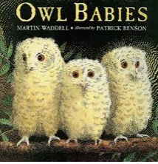



Jesus was a wonderful teacher and people came from far and near to listen to him speak. He used special stories called parables to teach people more about God.

Today we are going to learn more about one of Jesus’ parables.
Today’s parable is The Wise and the Foolish Builder.
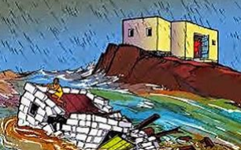

The Wise and the Foolish Builder
Read the parable in the Bible Matthew 7:24-29
You can watch it following this link
https://www.youtube.com/watch?v=I6S3cRVLMFQ
You can read the story below.
Jesus told a parable about 2 men who each decided to build a house. The two men went out looking for the perfect place to build the house.
The first man was very wise. He thought carefully about the kind of house he wanted to build. He wanted a house that was strong. If a strong wind or heavy rains came he did not want his house to break up or wash away. The wise man knew that the most important part of a house is the foundation. The foundation is the first thing that is built. It is at the bottom of the house. The foundation has to be sturdy and strong to make the house sturdy and strong.
The wise man looked everywhere and then he found the perfect place. He found a huge flat rock. The rock could be the foundation for his house. The wise man dug around and chipped the rock until it was the perfect size for his house. Then he built his house on the rock. After it was finished he lived in the house. Many times storms came to his house. The winds blew and the rains came but the wise man sat comfortably in his house. He did not worry about the storms because he had built his house on the rock.
Another man built a house but he was foolish and didn’t think carefully about the kind of house he should build. He just found a nice flat place and started building. He built his house on the sand because it was easier and quicker. The foundations kept slipping and sliding in the sand but the foolish man didn’t care. When the house was finished he moved in. Guess what happened when the first storm came? The foolish man’s house fell apart because it did not have strong foundations.
After Jesus told this story he explained what it meant. The wise man is like someone who listened to Jesus’ instructions and followed them. Jesus’ instructions are always right. When a person builds their life on Jesus’ teachings they are building strong foundations and they will be strong inside.
The foolish man in the parable was like someone who does not follow Jesus’ instructions and does not build their life upon Jesus. A person like that will not have strong foundations and will be weak inside.

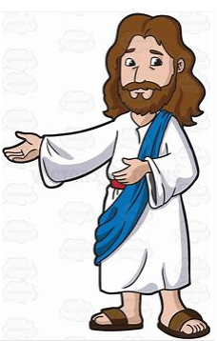
Ev
Everyone who hears my words
and puts them into practice is
like a wise man.
Matthew 7:24

But everyone who hears my
words and does not put them into practice is like a
foolish man.
Matthew 7:26

Reflection
So what does it mean to put Jesus’ words into practice?
I’m going to give you ideas of things you could do. If you think they are wise, make your hand into a fist shape so that it looks like a rock. If you think it is foolish, say ‘whoosh!’
- Being horrible to your little brother or sister
- Obeying your parents or carers
- Praying for a friend
- Cheating on a test
- Sharing with those in need
Sometimes it’s hard to follow Jesus but when we choose to do what Jesus says and obey his words, then we are being wise!

Prayer

Dear God, help us to be like the wise man in the story. Help us to trust you and to follow your ways. Amen

Craft Activity You can make your own house on the rock and on the sand using these ideas.
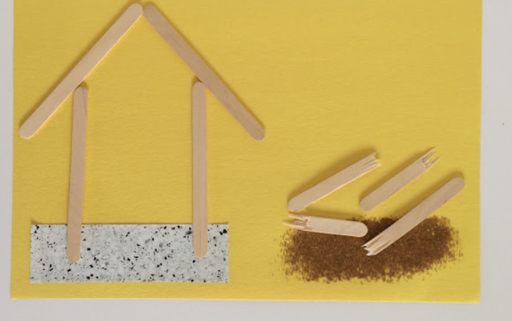

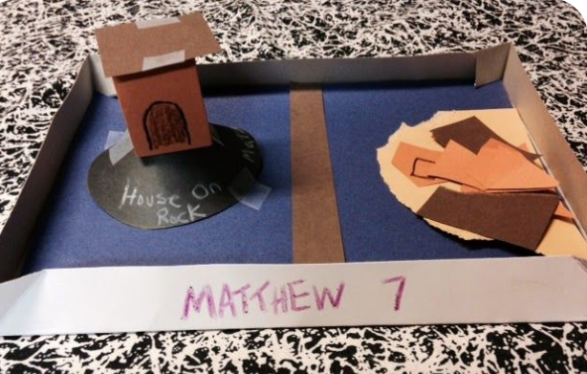
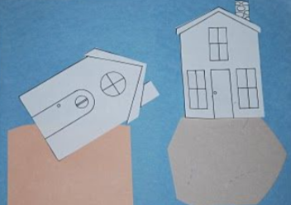

Colouring Sheet
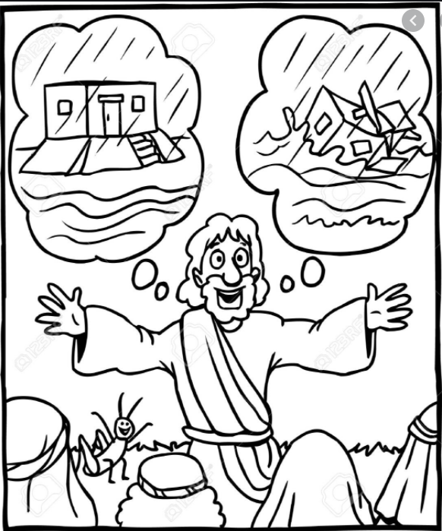
Song
https://www.youtube.com/watch?v=3HVdbULOVHA

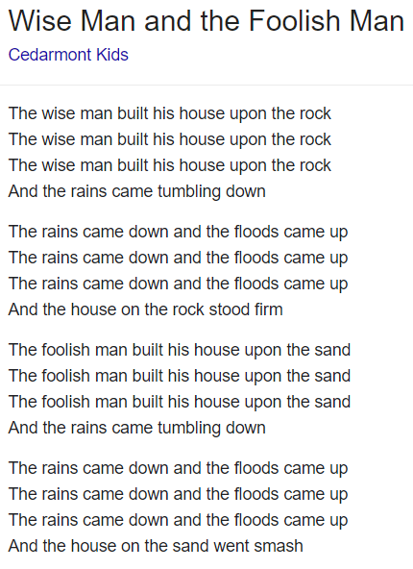
Hope you have enjoyed the activities this week.
There will be another Kings Club web site lesson in 2 weeks’ time - 15th November.

If you make the craft activity or colour in the sheet beautifully take a picture and email it to church.
We will look forward to seeing your creations!

God bless you all

